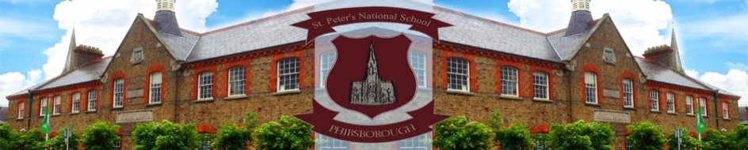

St. Peter’s National School,
St. Peter’s Road
Phibsboro,
Dublin 7

First day questions

What happens on the first day of school?

- Bring your child to school between 9.10am and 9.20am. By doing this you will avoid the main rush between 8:38a.m. and 8.50am.

- Take your child to her/his classroom and greet the teacher.

- After a few minutes tell your child you will see them later and leave the room. It is important that not too many parents are in the room at the same time.

- Make sure we have your contact numbers.

- Please collect your child at 11a.m. They will be brought to the door for you.

What should my child have for the first day?

- Just a light lunch, including a drink. Make sure the box and bottle are easy to open and has your child’s name on it.

What about collection times?
- Please refer the timetable you received in your new entrants’ pack.

What about after that?
- Each morning, the children will get into their line outside the classroom from 8.38am. Their teachers will come to collect them.

- From_____________ , school will finish at 1.30pm. Please complete the form indicating who will be collecting your child from school. We only allow children leave with authorised persons.

- Remember that when you are collecting your child, many other parents are collecting their children too.

- Children who go to After School Care Services are collected and must be signed out. Please let us know which After School Care Service your child is going to; any changes to that should be given to us via email or in writing through the office.
1

