•The Camping Trip•
By Bianca Dancuta
Today would be a good day. The professor announced that today we’ll have a camping trip near the woods and we’ll be staying in cabins. I was really looking forward to this trip, so without hesitation I changed into some sporty clothes and my runners and packed my bag since I didn’t have time yesterday. When I arrived I was just in time and saw the bus. The teacher told us yesterday to pick a partner and we’ll be having that partner for the rest of the trip. I picked my best friend Shayla . When we got in the bus all of my classmates were enjoying themselves as well as the teachers. Me and Shayla talked about what we’ll do when we get there and making up silly theories. The bus ride was only 1 hour. We got out and admired the amazing scenery and the big green trees. Soon enough there was this man who looked liked he was in his mid 30’. “Welcome everyone! We’re so happy you made it here. I’m sure you’ll enjoy this trip since we have some exciting activities planned out for you. You’ll be sleeping in the cabins and there will be bunk beds inside. So without further ado, lets begin. Follow me.”
We started following the man and I still couldn’t get over the amazing view. The leaves were crunching when we stepped on them and every now and then the sun will randomly pop up in our eyes,so we had to wear sunglasses for most of the day. When we stopped everybody started getting excited. We saw the cabins and they were beautifully decorated with leaves and some flowers. We started getting inside the cabins that were arranged for us and immediately plopped on the bed. I didn’t even bother getting my bag off my back. A couple of hours passed and it was time to go to sleep. I remember the teacher saying we’ll be staying here for 3 days. I got my pyjamas on and drifted off to sleep.
I woke up the next day excited. I put on my t-shirt and sweatpants and runners. Today was going to be a relaxing day since it’s only the first day we got here. We first started doing a jog around the woods with the man that showed us the cabins. He told us his name was William but we called him Will for short. It was a nice jog and we were all starving so we ate a delicious breakfast. We had pancakes with syrup and strawberries on them. Now it was our free time. The boys played some football while the girls were making flower crowns. Time flew by again and it was night time. I put on my pyjamas and went to sleep.
The next day was going to be good since we’re making s'mores! But that will happen later. We ate breakfast and went to do some P.E. We ate lunch and later on we climbed some trees for fun. It was awesome. The time came, and we’re making s'mores! We sat on some logs and there was some fire to warm them up. We decided to tell funny stories and joke about lots of things. We all started to ease up on Will and we got used to him. It was 23:00pm and we were all tired so we walked back to our cabinets. Just as we were walking, I heard a weird rustling sound. I didn’t think of it that much,but something told me that I have to hurry up and get inside. I listened to my gut feeling and started jogging. Shayla followed me and told me” Hey, what’s wrong?”. “It’s nothing,I guess I’m just really tired and want to sleep.” I lied. I never liked lying to Shayla since she knows how to spot a liar. “Alright there’s something you’re not telling me,and it looks important.”Shayla said. I started telling her about the noise and my gut feeling. “Oh my Gosh Layla, you’re just overreacting. What, you think this is some scary story? Just because it’s night time and you hear weird noises doesn’t mean it’s something dangerous. Besides, it’s probably just the wind.” I felt a little better but I still could feel something was wrong. Just as we were almost there, I heard the loudest screech ever. It wasn’t one of my classmates, it wasn’t the teacher and it wasn’t Will. The screech sounded like it was in pain. We all started panicking and we were all pushing and shoving each other just to get to the cabinet. Me and Shayla got inside and breathed heavily. “I told you!” I said to Shayla. We couldn’t sleep that night. We were determined to find out what that was.
We decided to search the cabin everywhere for clues or anything helpful. It was then that I found a book. It was about the creatures that lived in the woods. “I think we got what we needed” I said. We flipped and flipped the pages until Shayla said “Stop! There it is!”. “How do you know, we don’t even know how it looks like.” She told me she looked up and saw that it was a blue light, very faint but visible. And that there was a face on it. “Shayla that’s no creature.. that’s a spirit. We can’t stay here any longer! Who knows what it will do! We have to warm the others.” We opened the door and went as quickly as possible, cabin to cabin and told everyone about it. Even Will and the teachers. We all packed up immediately and luckily as we ran we saw a bus down the road. The bus driver was there and begged him to take us all back to home. It was 01:00am in the morning. The bus driver dropped all of us off. We all live somewhere in the same neighborhood so we all walked but jogged on our way home. I got my keys out and opened the door and immediately went to my mom. I told her everything and she told me I’m safe now. I’ll never forget this day.

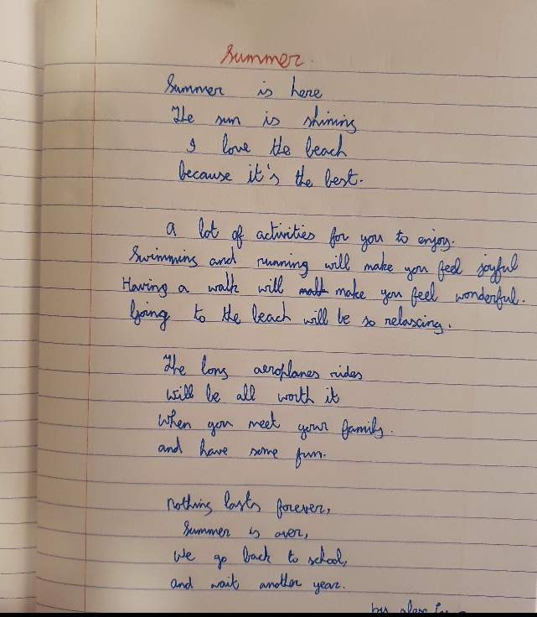

By Alex Lazar

Summer Fun

By; Liya Sibi

It was a hot, warm day. Anna had a flight to catch to the Bahamas, perfect for the summer holidays. The airport was packed as so many people were going on holidays and there were so many planes taking off. After a few hours of waiting, her flight was ready to take off. In the cockpit, the pilots were doing checks for the takeoff, making sure everything was good to go. The plane safely took off.
After a while Anna could hear a weird noise coming from the side of the plane. She looked out of the window and couldn't see anything. " Odd.." she thought. "I might as well inform the flight attendants." The flight attendant said there was nothing to worry about but Anna knew something was wrong. A few seconds after, the cabin started filling with smoke. "Please fasten your seatbelts, we are experiencing some turbulence." she heard from the intercom. It started getting really bumpy and the oxygen masks came down. The oxygen was running out. She couldn't see any flight attendants and decided to go check what was happening. She opened the cockpit door and saw both pilots unconscious as their oxygen had ran out.
She moved them to the back and got into the captain’s seat. "Hello? ATC? I don't know what is happening to the plane please help!" There was no answer. She got out and saw nearly all passengers had passed out. She looked through the window and saw a fire on the right engine. She went back into the cockpit and decided to lower the plane to a safer altitude to have some air pressure. Her speed was 135 knots per hour. She read some emergency procedures for engine fires. "Shut off fuel, emergency descent..." she read.
Suddenly the plane was dropping and dropping at a very high altitude. Anna woke up. She was in her bed, in the Bahamas. "It was just a dream after all."

Summer Fun
By Nasriyah Hamza
My family, friends and I went to France for the holidays.
So we were woken up very early in the morning since our flight was first thing in the morning. We got changed and we went to meet our friends in the airport (Bana, Debbie, Betty, Daniel and their parents). We went through security and stuff and we then we boarded the plane.
About 1hr 30mins later we arrived in France. We stayed in this huge house that had a lot of rooms. The house also came with a HUGE garden and there were a few cats which was one of my favourite bits about staying in the house. We were all very tired so we just spent the rest of the day in the house resting.
The next day we went and bought baguettes for breakfast and we had them with this delicious tuna salad. After breakfast we went to Disneyland. It was so much fun we took a train to Disneyland. Most of the rides Hamza couldn’t go on because we were very young I was about 7, 8 or 9 when we went to France and Hamza is three years younger than me so he couldn’t really go on many ride sadly. While we were in Disney we had lunch and dinner and then we went home.
For the other three days we went out shopping and going to parks and stuff and on one of the days we had a splendid barbeque.
A day before we were going to leave we went to the Eiffel Tower as I said before I was young at the time so I was really scared so I didn’t end up going to the top of the tower.
The next day we packed up and we went back home to Dublin. France was amazing 10/10 recommend.
The End.
Summer Fun
By: Leanne Chiriyath
Oh Summer – longer days, brighter days, trees full of leaves, lovely flowers and colours everywhere, no school, playing with friends, cycling, barbeques, beaches and loads of fun. Everyone loves summer. Well almost everyone… Everyone except Jacob – a 12-year-old boy from Dublin. He hated summer. Jacob loved his granny Lily very much. He spent every summer with his granny doing fun activities. His granny was full of life and his best friend. But 2 years ago, his granny died suddenly and it was a great shock to him. His granny called him “Big boy Joe” and he missed her too much. He did not enjoy summer at all after that. While everyone was going to the beach, park or going camping Jacob would stay inside and be a couch potato - watching TV and playing video games. One summer day, Jacob went to the supermarket with his mom. He went only because his mom asked pestered and pleaded with him almost hundred times. But he had a condition, he would wear a coat and a cap although outside it was 30⁰C. Instead of blending in, he stood out and everyone was staring at him. While they were shopping, a girl who was about his age came up to him and asked him, “Hi Jacob, do you want to be my friend, big boy Joe?”, “How do you know my name and who are you?” asked a surprised Jacob. “My name is Lily and I live around here. I know a lot about you, like you hate summer!” Lily replied. Jacob was astonished, because his granny’s name was also Lily. And before his granny died, Jacob’s granny showed him pictures
of herself when she was younger, and this Lily looked just like his granny. “That cannot be. But this girl looks kind and trustworthy so I can try and be her friend” said Jacob to himself. “Ok” said Jacob. “I will be your friend”. “Thank you” said Lily, “Get ready for the best summer you will ever have, you are going to have fun this summer, big boy Joe”. After that, every single day, Lily and Jacob were doing summer activities and not watching TV at home! Jacob couldn’t believe that he was actually having fun. He didn’t know what was happening to him but with Lily he was enjoying himself. Jacob’s parents were also really astonished how much Jacob had changed. Lily was always there with Jacob. They went to the movies, walked on the beaches, swimming in pools, having a barbecue, going camping, doing karaoke, making pizzas and taking pictures together. Jacob didn’t realise how time passed but soon it was end of summer. “Thank you, Lily this was definitely the best summer I had!” said Jacob. “You are very welcome big boy Joe. It was so much fun. You should enjoy every summer like this” said Lily. “Yes, we will Lily.” said Jacob. For the last time Jacob and Lily took a picture together, but when Jacob looked at the picture, Jacob was the only one in the picture. “Where is Lily? Why can’t I see her?” wondered Jacob. When he turned around there was no one there. He looked up to see the sky full of stars and some stars arranged to say “Bye big boy Joe, Summer Fun”

The Apple Tree
By Reamae Gutierrez
There once lived a boy named Raymond, he was just another man, athletic, shy and nice. Raymond likes going to a certain tree in a field every summer and just sit by there and look up at the sky, he didn’t mind what the weather would be, as long as he got to look up at the sky, he would be happy. He called this place ‘the Apple tree ‘.
On one particular summer day, Raymond was heading down the hill towards the field to do what he usually did, sit down and look at the sky. To his surprise though, there were two people there. They look quite similar. Are they twins, Raymond thought as he walked towards them.
They both had fair blonde and wore these old looking clothes, like the one should would see rich children back in the 1900s. There was a boy and a girl and they both looked like they we’re around the age of 7. Raymond could barely see their eyes, but they looked like they were in a light shade of grey. Somehow, they looked as if they were dead.
“Hey you two! “Raymond shouted a few meters away from them “Who are you? And what are you doing here? “The two of them looked at Raymond and then back each other. The boy signalled Raymond to come towards them. Feeling wary, Raymond cautiously walked towards them. “How can you see us? “the girl asked in an innocent tone. Raymond replied “I dunno. Who are you? And what are you doing here? “The two children looked at each other again, then looked at Raymond, but this time their gaze looked more serious. Raymond felt like their eyes were piercing through his soul.
Eventually, the boy then spoke “You have now made a spiritual contact with us. You are now obligated to show us what makes summer ‘fun ‘. Failure to do so and your soul will burn. If you do complete this task and you will receive a special key from us, that key will then help you find the reward. You have the rest of this summer to do this task. Good luck. “and then they transformed into a more human looking version of themselves, yet their eyes still were in the grey shade. Raymond without question, started thinking of places to bring them. “Maybe the water park. They could have fun there. Then again, I have the whole summer to do the task. I should be able to show them the fun of summer “
Raymond brought the two children to many places, the theme park, swimming pools, shopping malls and more. They all had fun together and they got to know each other. They twins went by the name Gemine. They never understood the concept of Summer and always though it was pointless. They had done the same thing they did to Raymond to many other people but all of them failed, either because they forgot about them or that they didn’t believe them.
On one day, Raymond brought the twins to a photo booth near the shopping mall they were at. They took many pictures together but all that came out was just Raymond smiling by himself. Then the realisation hit him that they were just ghosts who wanted to know what was fun about summer. They would be gone once summer ended.
Soon enough summer then ended. The twins met Raymond at the Apple tree. “Hey Gemine, will I ever see you two again? “Raymond asked. The girl handed Raymond a key with an Apple hanging from it. The boy then pointed at the tree. A little lock was at the bark of it that Raymond never noticed. He put the key inside it and a bright light shone. The twins disappeared and all that was left was a locket. Raymond opened the locked and inside was a picture of the three of them, smiling. Tears started forming in Raymond’s eyes. He felt sad knowing that he might never see them again, but happy that they knew what summer was really about. There was text carved into it saying ‘𝓣𝓱𝓪𝓷𝓴 𝔂𝓸𝓾 ‘That was the best summer Raymond ever had.

SUMMER FUN
By Owen Brato
It felt as if she was on the tallest building, peering down on the ground below, ready to jump! When Jessy let go of the bar she flew down, shouting in excitement. Jessy reached the exact altitude that the instructor said to release the parachute.
She pulled the string on her bag and out came the parachutes. They pulled her up and Jessy glided down. She could see a great view of the town and mountains below her.
Earlier:
Jessy heard the growling of the engines of the new Summer cruise Zeppelin as she ate her breakfast in the café. Looking out the window she saw clouds so close she could touch them. Jessy had bought a ticket for the Summer Holidays in The Summer Zeppelin. She would spend her summer in an air cruise.
Jessy took out a booklet and read the next activities for today. Today they were going to go sky diving at three o’ clock. An announcement came: “We are now over the British canal! If you look outside the windows you could see the lovely view of boats and sea” it said.
Jessy looked down through the window and saw a fantastic view. It was sky diving time and a group of people were taken to a room where there were parachutes. An instructor came in and lectured the group about how to eject the parachutes and fall safely down.
After the lecture, Jessy and the group were taken down stairs and to the ship’s gondola where they were going to jump out from. They went in a room and saw controls and crew. This was the control room where the zeppelin was steered. On their left was a door to the outside air. The group made a line beside the exit and each person held a bar.
The exit door opened and Jessy saw them jump out and glided down from the window beside her. After a while it was her turn to go, Jessy was a bit worried but excited.
Later:
Jessy sat on her bed. She opened a cupboard beside her and got her diary out. She also took out a pencil and wrote what she did today and the activities. Tomorrow would be the last day when they would return back to Germany, ending their summer trip. Jessy hopes she would come back to the advanced Sister of Hindenburg next summer.

SUMMER FUN
By Grace Cahill
One February, a girl called Justine was told she was moving to Namibia. “What! I like living in Ireland!” she cried. “Now Justine, we aren’t moving until June, we still have time.” said her mum. “Why do we have to move, and so far away!” she said. “Well, you know my job with the organisation for rescuing elephants from poachers?” asked her dad. Justine sat back in her living room sofa and crossed her arms. “Well someone wants to buy it and I need to go and see if we should sell it, please Justine, try to be optimistic.” He pleaded. Justine stepped off the plane. “Namibia, here I come.” she whispered to herself. She had been researching Namibia the past few months and was ready for the change. A few days later, the family had almost settled in and Justine was out on a walk. “Hello, my name is Aina. You are new here, yes?” asked a cheerful girl. “Um, yes, I’m Justine, I didn’t think anyone knew English here.” said Justine, a little startled. “It is a main language.” Aina grinned, “Do you find it hot in Namibia?” she asked. “Yes, how do you survive?” asked Justine. “You get used to it.” she replied. “To be honest, I thought Namibia would be a desert filled with lions.” said Justine. “Some of it is. This is the city.” Aina explained. Over the next few weeks, the two girls met at the same spot every day, at the back of a small kind of newsagents. Justine was happy she had made a friend, she never had any in Ireland. One day, Aina said, “Watch out for that scorpion.” Justine shrieked and turned around to see Aina laughing. Justine frowned. “Where do you see lions and stuff?” she asked. “On the outskirts of the city. I can take you tomorrow?” “Oh yes!” The next day, Justine brought binoculars with her. “Where have you been going on you walks?” asked her mum. “Just…around.” she replied and set off. Justine and Aina were looking at huge lions from behind tall grass. “We need to be quiet, that’s a whole pride,” Aina whispered. “Let’s go further, we might see an elephant.” “Best summer ever.” Justine whispered.

Summer Fun
By Joyal Jomy
In summer 2015, Billy’s and Timothy’s teacher decided to go for summer camping in a forest as it was their first time having their field trip, where they would have some fun experience in camping. They were going to have to bring their own camping tent for 2 people and their sleeping bags.
Soon the bus arrived to bring the summer camp pupils including Billy and Timothy to the forest. The teacher assigned the other pupils to place bear traps so that bears would not go near their camping area while Timothy’s and Billy’s job was to find wood to build their campfire so they can cook marshmallows
Eventually Timothy and Billy found plenty of wood so they earned a badge. Then they set up their tents near the campfire. Soon the pupils gathered towards the campfire. Together they ignited their unlit campfire which again they also earned a badge and as well as some pupils also. They opened a packet of marshmallows and then put them on a stick. Then the pupils began melting it. They sang songs then they told scary stories to each other.
Then they started to set up their sleeping bags so they can get ready for bed. They got ready then slept peacefully with the owl howling and the crickets chirping in their tents.
Soon the pupils woke up but had little time to leave. They packed up their tents and sleeping bags into their backpacks then got ready to go on the bus to leave the campsite. When Timothy and Billy asked each other about how their camping trip was they could say nothing other than “We loved it more than anything else”.
The End
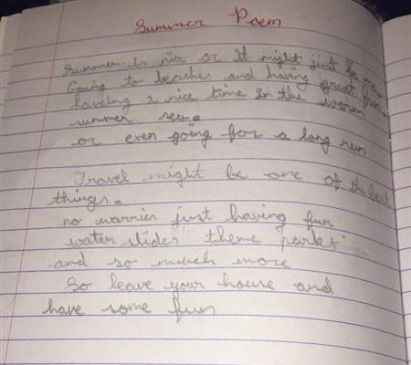
By Paul Giurgi
The Camping Trip
I jumped for joy, another year of school over! I was even more excited when I remembered that we were going on a camping trip today. It was my first time going camping but I wasn’t worried because my dad said he knew what he was doing. He said that he used to go camping all of the time when he was small. We packed our bags and left for the campsite.
The car journey was awful! Annie (my little sister) was crying the whole time and my dad was playing terrible 80s music at full volume. To make things worse we ended up getting lost! Dad insisted that we didn’t need a GPS but we used one in the end. By the time we got there it was nearly dark.
We drove through the big gates with a sign saying ‘BROOKWOOD CAMP SITE’. In front of us was a small building with toilets, a first aid room and a registration room. The rest of the site was just a big field to put up tents. There was also a forest and a small river.
We quickly registered for the week we were going to be staying at the campsite. The lady at the desk was impatient mainly because it was very late. Me, mum and Annie went to the bathroom and left my dad to put up the tent. That was a big mistake! We came back from the bathroom just in time to see the tent fly off into the small river.
We had to borrow a tiny tent from the campsite. This time we managed to put up the tent. We all got in and tried to get to sleep. Then it started to rain heavily. The rain was very noisy and I couldn’t get to sleep. Suddenly water started to make its way into our tent.
When the morning finally came I was the first to get up. My pyjamas were a bit wet but I didn’t mind. When everyone else was awake we had a small breakfast and got dressed into to hiking and rain gear. We were going into the forest for a hike. This time my dad didn’t mind bringing a map. We set off on our hike knowing that nothing could go wrong..... if only we had worn shorts!
By Cara Ruxton

Summer time is lots of fun,
when you get to play and run.
Getting burnt in the sun,
Oh that wasn't really fun.
Spending time with family,
And visiting a new country.
Watching sunsets every night,
Don't let the mosquitoes bite!
Catching fireflies in jars,
Observing the beautiful stars.
Later when you go to bed,
you remember what a wonderful time you had.
By Sasha Butala
A Letter by Gillian Canilang
To Savannah, my best friend
I had such a week I am going to tell you about one specific day we went on a holiday to America!
We decided to go the beach on such a hot day it was not a good idea! Me and my brother went over to the sea but it was actually still cold so we just went and ate ice cream and we went on a walk but it was still pretty hot so we sat down and ordered water with ice and then we went back on the walk. From then it got cooler and then after went back of the beach and we just sat down and we just had a dip in but only our legs then we dried off.

We walked around and we saw a beautiful view of the beach so I took a picture of it with my polaroid camera but then we started to get hungry so we got watermelon it was so juicy and nice I accidentally swallowed a seed and my brother convinced me it would grow in me so asked my mom and it was not true I got so worried. It started to get late around 6pm so we went back home and ate dinner. What did you do?

From Gillian
P.S I know its winter for you there in Australia but was it snowing? I love snow, Oh I also drew a picture of what I did I hope you like it bye!!
Summer Fun By Serah Saju

Put on sun cream
and rub it in
perfect for
my summer skin

On my bike
Or in the pool
A sip of water
Keeps me cool

Shades are on
Flip-flops too
In summer there’s
So much to do!
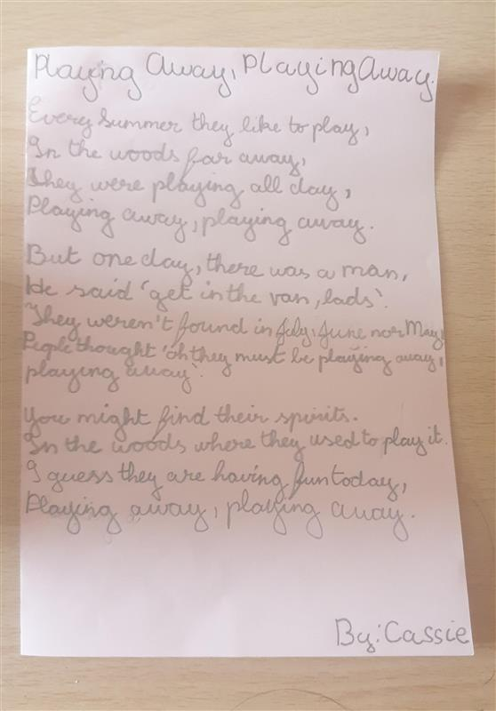
By Cassie Alkonga

