ST. PETER’S NATIONAL SCHOOL OPEN EVENING

We

We would like to invite you and your children (new junior infant entrants and new entrants from senior infants-6th classes for the 2023/2024 school year) to our first official open evening.
Where: St. Peter’s National School, Phibsboro, Dublin 7 (D07F75C)
When: Tuesday, 15th of November 2022
Time: 6:30p.m.-8:30p.m. (Brief guided tours of the school will take place at 6:30p.m., 7:00p.m. and 7:30p.m. with refreshments and school related stands in the hall following our mini tours)
Whether you are someone who lives in the local community, a prospective parent or a past pupil, please join us on the night!

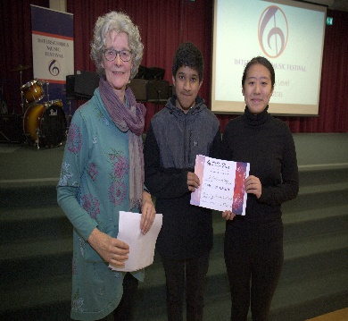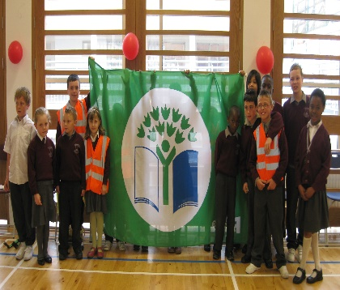

If interested in attending one of our designated tours on the night, please email rryan@stpetersns.net stating your name, child’s name (if a prospective parent) and your preferred time of tour (6:30p.m., 7:00p.m. or 7:30p.m.) by Wednesday, 9th of November. Please also see our school website (www.stpetersns.net) for additional information.

