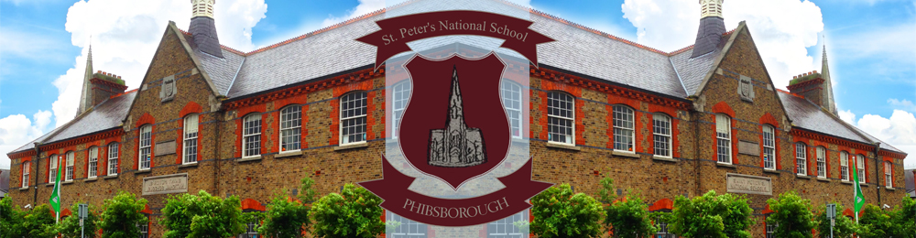
St. Peter’s National School, St. Peter’s Road, Phibsborough, Dublin 7
Telephone: 018680501 E mail: office@stpetersns.net

SCHOOL CALENDAR 2022-2023

TERM 1
30th August 2022 School Re-opens One arrival (Junior Infants staggered)
31st Oct.–4th Nov. incl. Mid Term Break School Closed
7th November School Re-opens One arrival
21st December Christmas Holidays Times will be communicated in advance

TERM 2
5th January 2023 School Re-opens One arrival
6th February 2023 School Closed Public holiday
7th February 2023 School Re-opens One arrival
13th – 17th February incl. Mid Term Break School Closed
(school will close on Friday 10th February at 2.30p.m.)
20th February School Re-opens One arrival
Friday 17th March St. Patrick’s Day School Closed
Monday 20th March School Re-opens One arrival
Friday 31st March Easter Holidays Times will be communicated in advance

TERM 3
Monday 17th April School Re-opens One arrival
Monday 1st May Bank Holiday School Closed
Tuesday 2nd May School Holiday School Closed
Monday 5th June Bank Holiday School Closed
Tuesday 6th June School Holiday School Closed
Thursday 29th June Summer Holidays Times will be communicated in advance

**Please DO NOT take holidays during school time.**
*PLEASE COLLECT YOUR CHILD ON TIME*
THIS CALENDAR MUST BE KEPT IN A SAFE PLACE and is subject to change.
Where contingency arrangements are required, St. Peter’s N.S. may reduce the length of the mid-term break or Easter holidays due to unforeseen school closures.

We would like to remind parents not to leave their children unsupervised before school in the morning as the school opens its gate at 8:40a.m. each morning and the school is NOT responsible for the supervision of pupils before that time.

New school year (2023/2024) will commence on 29th of August 2023.

